The Demo Of the Application :-

Short Description of the project:-

The application can be used to manage expenses of a person. User can add the income as well as expenses via the application. Moreover, they can be drilled down on basics of category, account type

To start with the demo please follow below steps:

Enter the site - <http://my-manageexpense.s3-website.us-east-2.amazonaws.com/>

User will see below screen .

Click on the login button on the top right.

Clicking on the same, will redirect user to Login page of Auth0

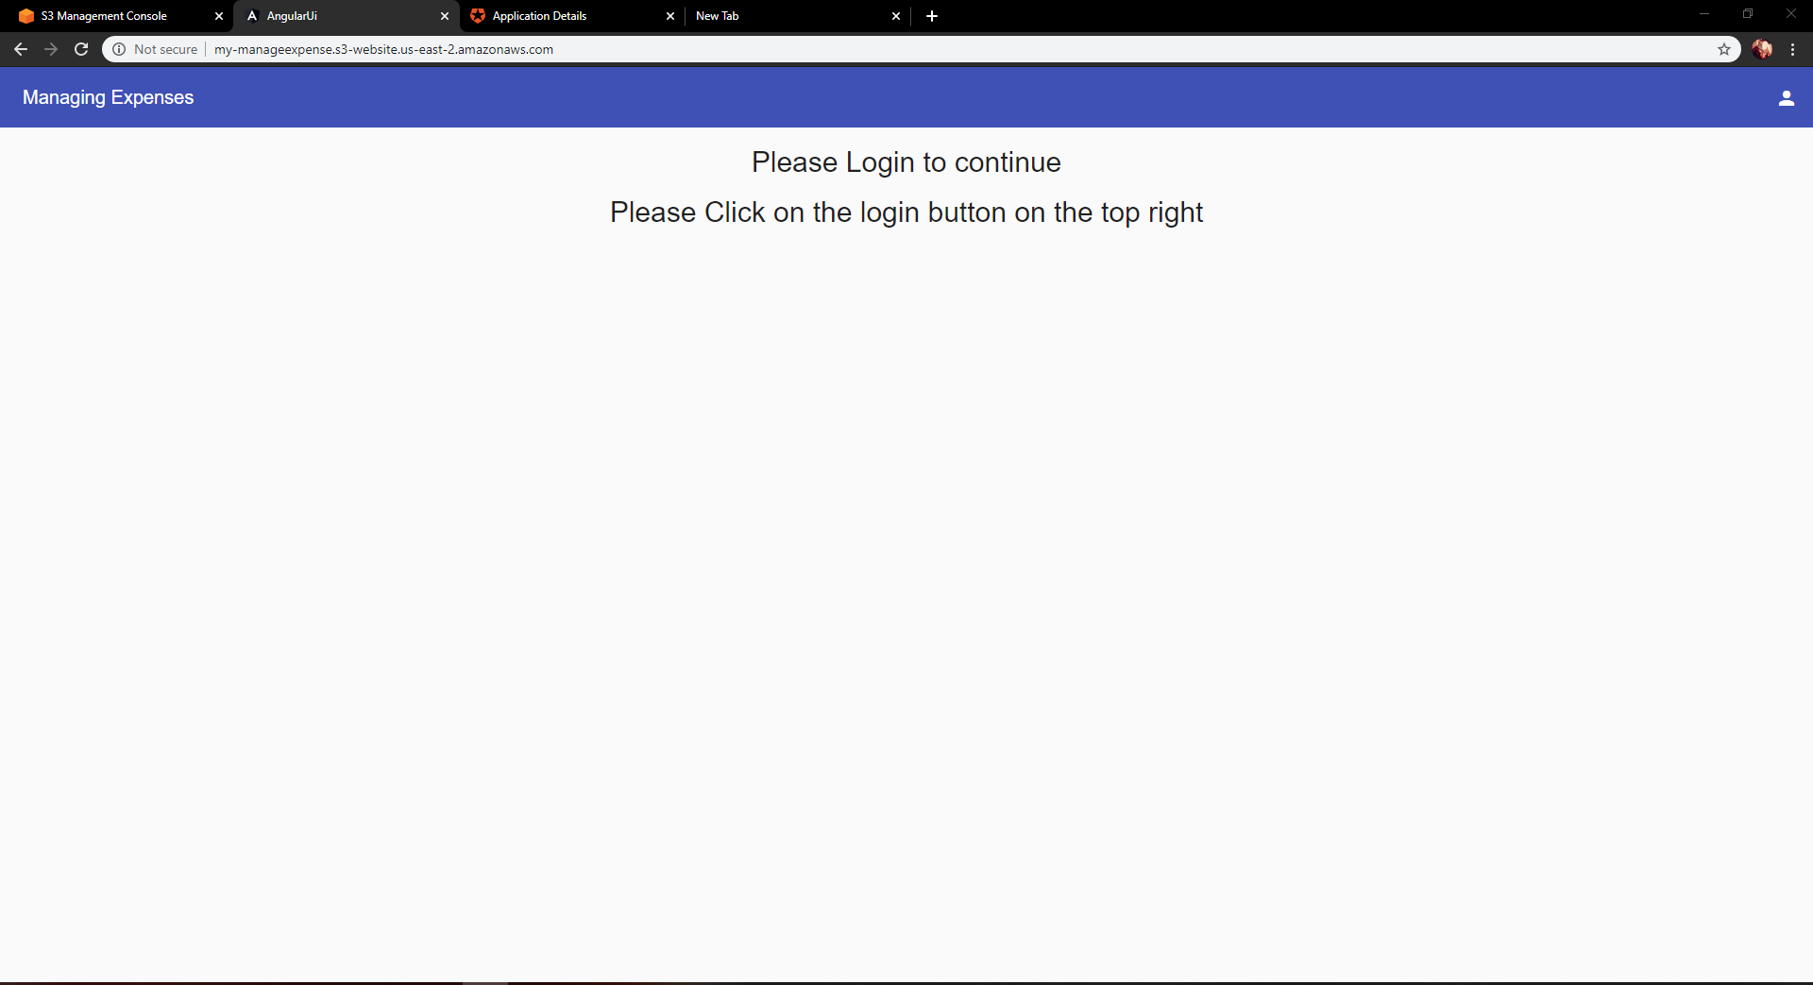

Sign in with Google Account.

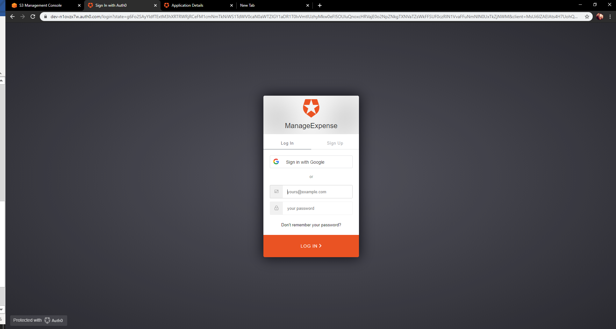

After successful sign it. User will see below screen .

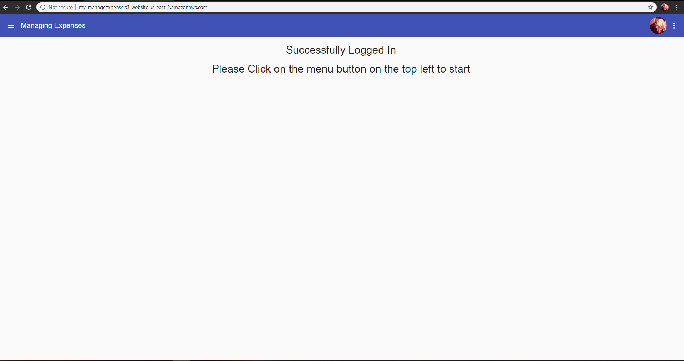

Now click on the top left menu icon, which is a navigation button. After this click on Category.

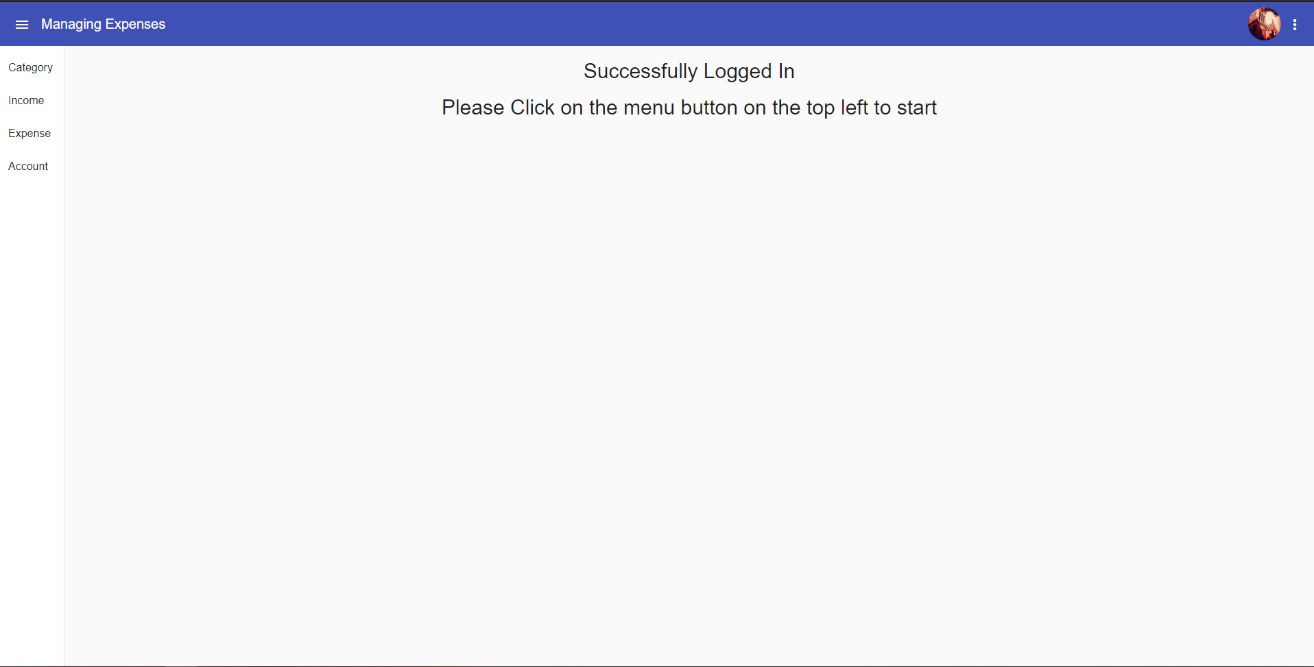

# Category

After clicking the Category, user will first need to create a category. Please create category for both income as well as expense.

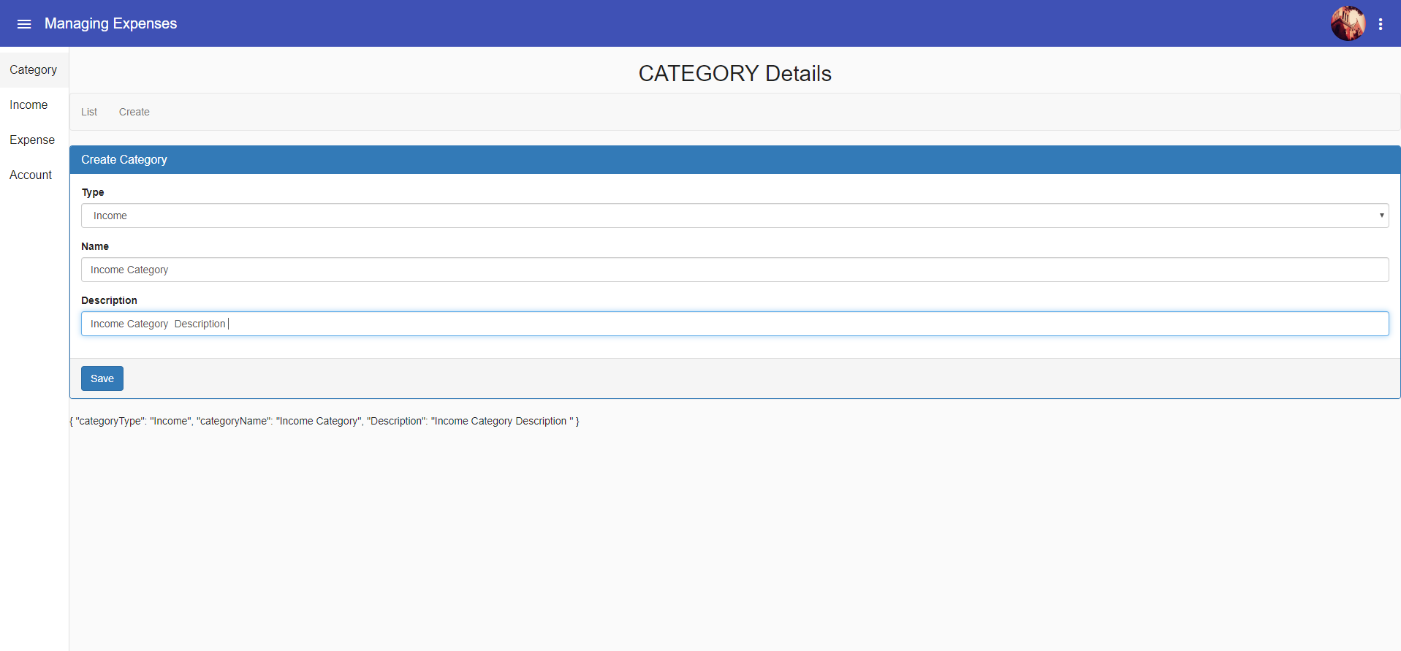

After clicking save, user will be redirected to the list page of category, where you can see the category you have added.

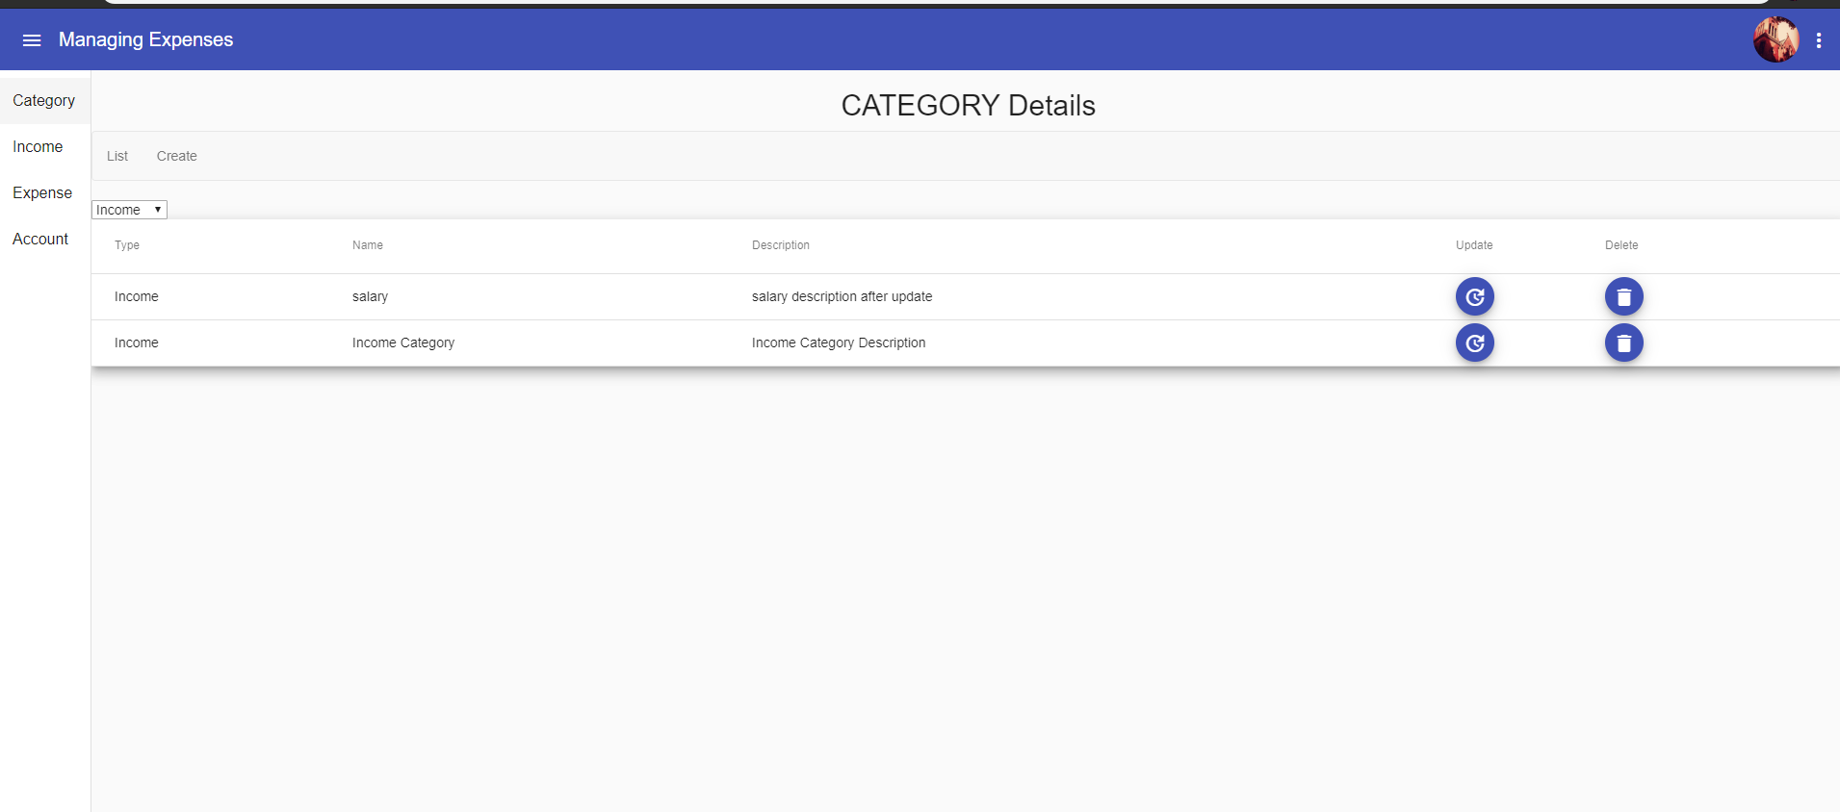

I have added a screenshot for adding income type category, please create one more category for expense type category.

In the list page, you can select which type of category you want to see. When user select expense type, all the categories of the expense type will be shown.

Please note, we will get the entries of categories as per the user.

Along with this, user can update and delete the Category as well.

# Account

After doing CRUD operations on the Category, user needs to add account.

Go under the menu, click on Account and create an Account.

User can create any type of Account. The significance of account is to know from which bank, money is either deposited or it was withdrawn.

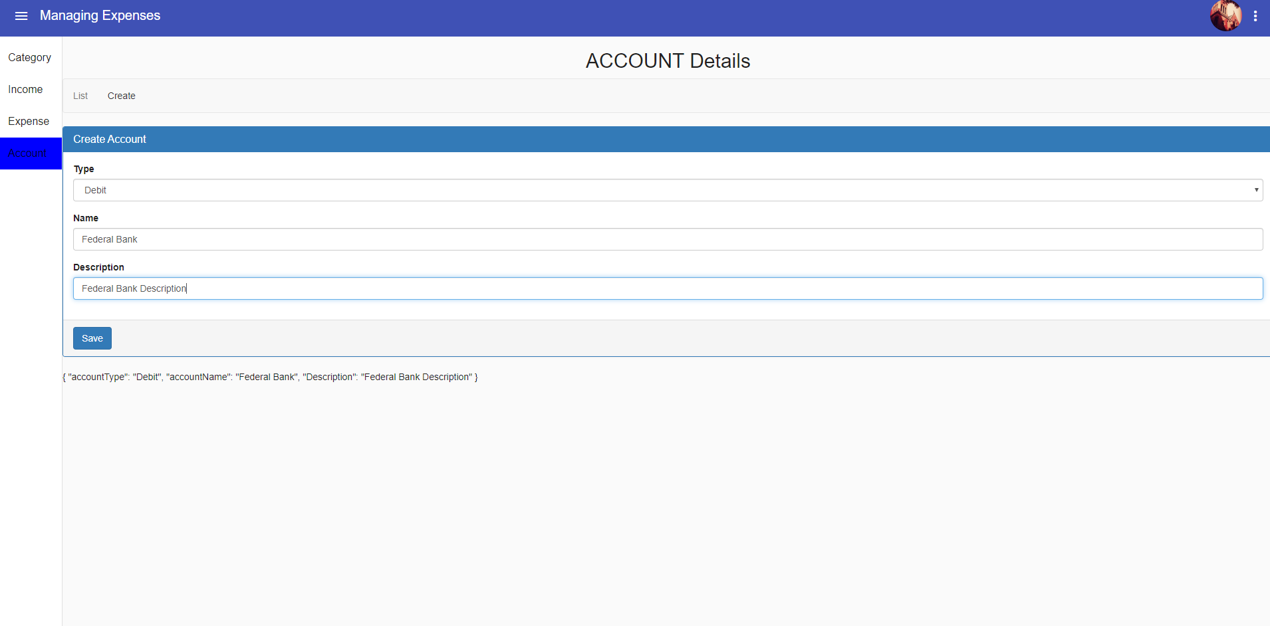

After clicking on save, again user is navigated to the Account List Page.

# Income

Now user can add income. User needs to add the amount, description, select a category and account

Category and Account will be shown in a drop down, and these values will be the once that have been added by the user.

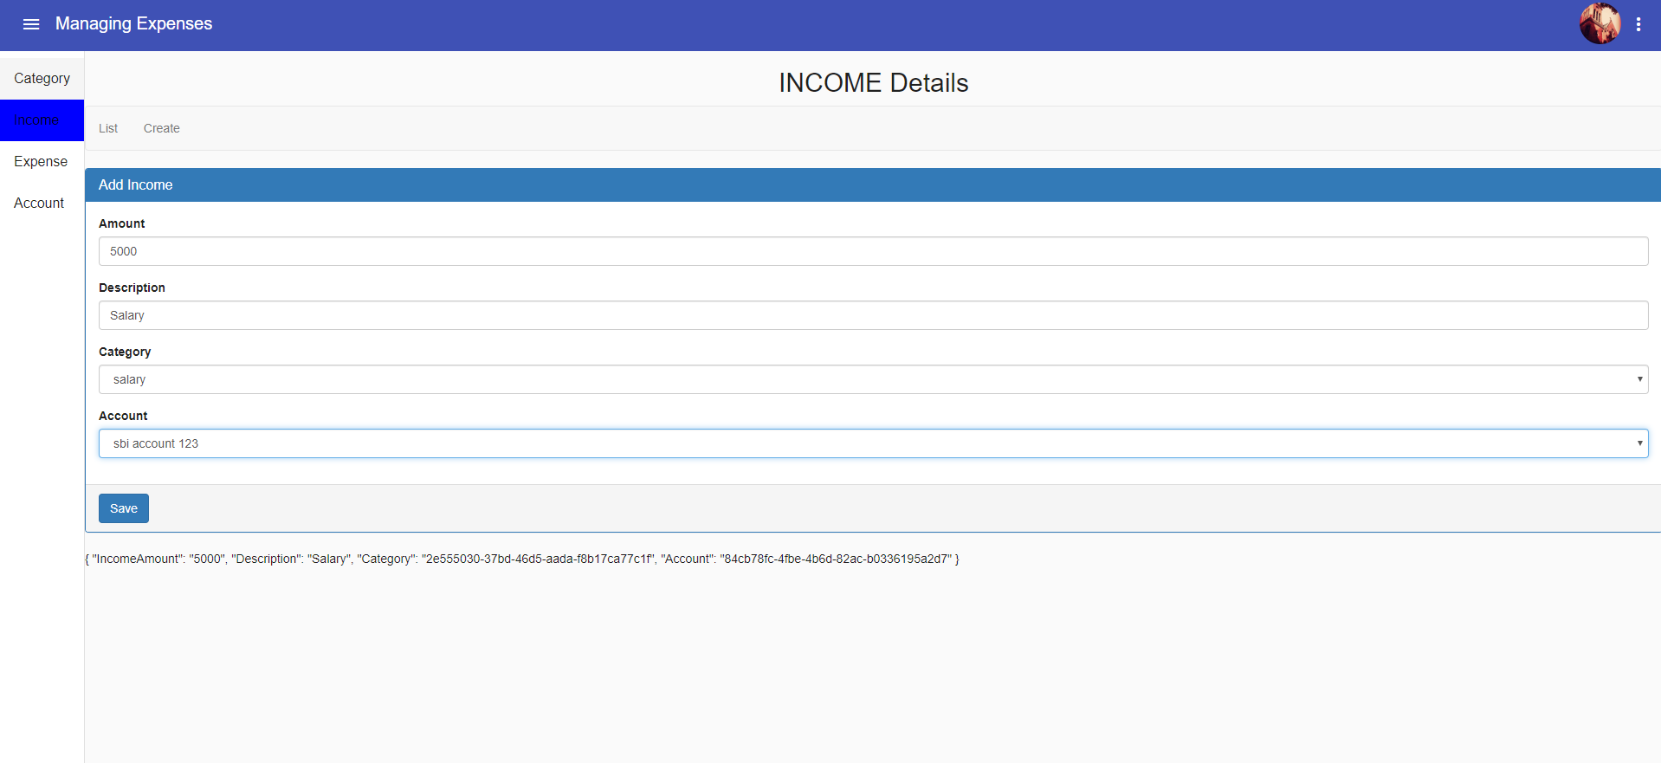

After clicking save, user will again be redirected to the income list. Here too user can update or delete the income.

# Expense

Expense and income are kind of similar pages.

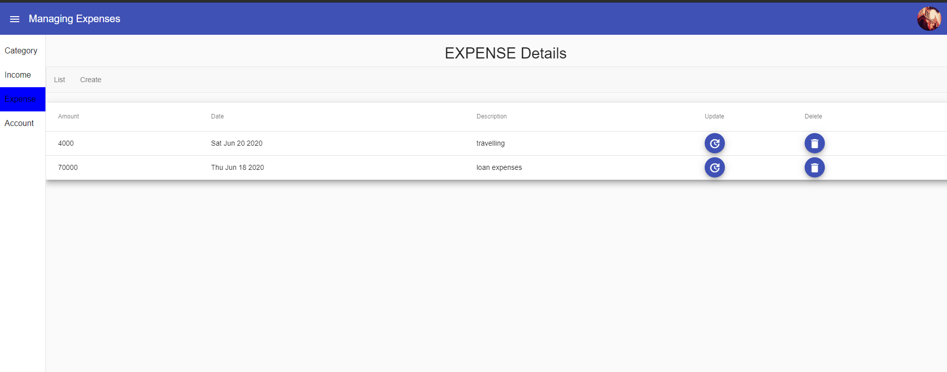

This is how a user will be able to manage the expense.

There is one more thing added is the S3 bucket, which will be used to store the images of the bill. Suppose a person wants to add a bill along with expense or income, the user will be able to do so. Due to time constraint I am not able to add in the UI, I have implemented the back end for it in the AWS lambda.

Postman Screenshot for same

Git profile links:-

Lambda - <https://github.com/anmolaggarwal21/ManagingExpenses>

Angular Site - <https://github.com/anmolaggarwal21/Manage-Expense-Front-end>

Note I have hosted the site on AWS S3 bucket.

Improvement: -

I have planned few things to improve the site, the first and far most is to give pagination in the grid of all list pages.

I have not included the validation in the front end